**Name- Vamika Mahajan Sap- 500096495**

**Rollno- R2142211138 Batch- B-6**

**Object Oriented Programming Language Lab**

**EXPERIMENT 9 Threads**

Q 1- Write a program for generating 3 threads. Thread-1 and Thread-2 are instances of class Demo1 which inherits the Thread class. Thread-3 is an instance of class Demo2 which implements the Runnable interface. Thread-1 prints even numbers from 1 to n. Thread-2 prints odd numbers from 1 to m. Thread-3 prints Fibonacci series up to y. Implement the program using synchronization methods of Thread synchronization.

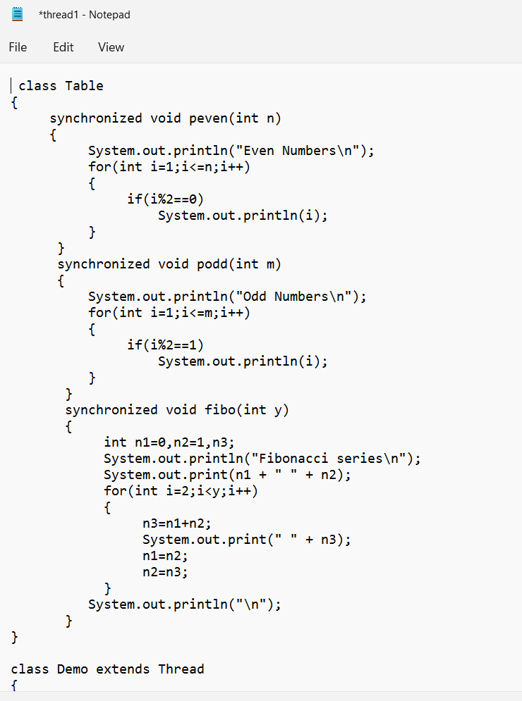

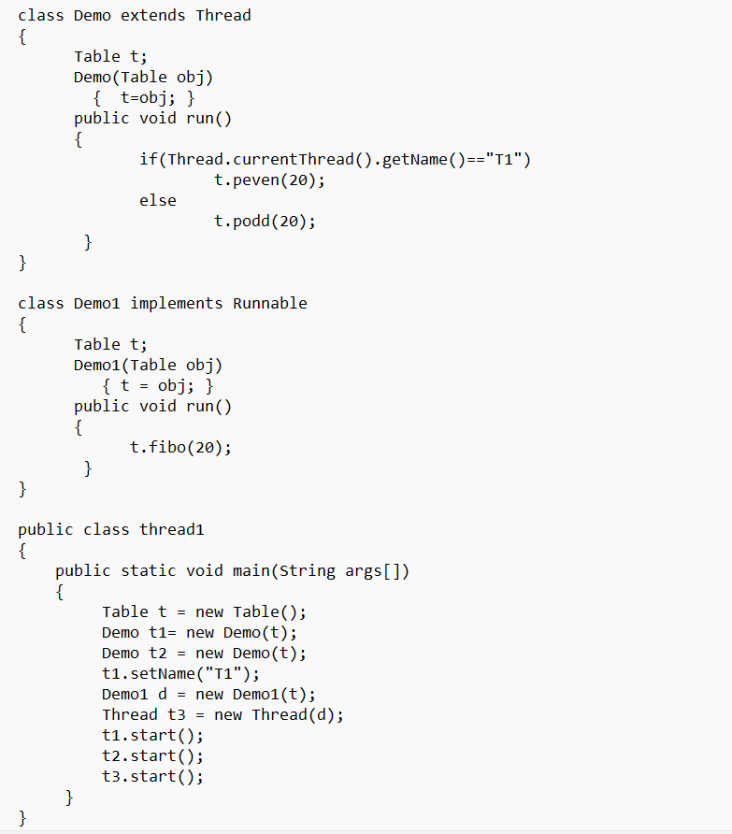

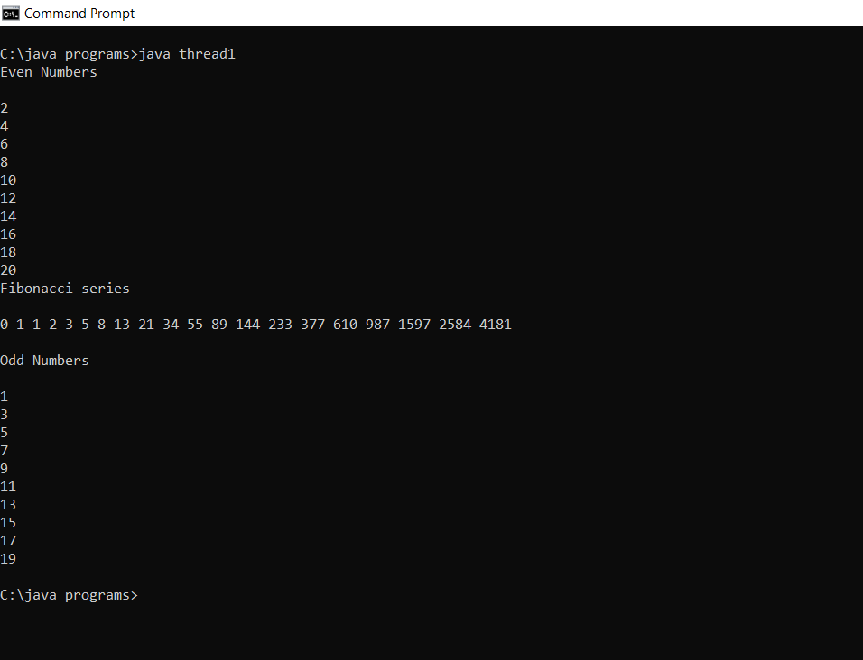

Q2- Design a java program with class "Travel" with a data member available seats and member functions book(int) and cancel(int). The object of class Travel is shared with 2 threads and each thread can perform either booking or cancellation of tickets. Implement the program using Thread cooperation.

